Functional Electronic Circuits Lab6

Student Name: CAO Xinyang

Student ID: 20321308

**My variant:**



It means Subtract rs1 from rs2 and write to rd.





**The pictures and explanation of the provided instruction execution:**

1. **PC moves two bits to the right.**

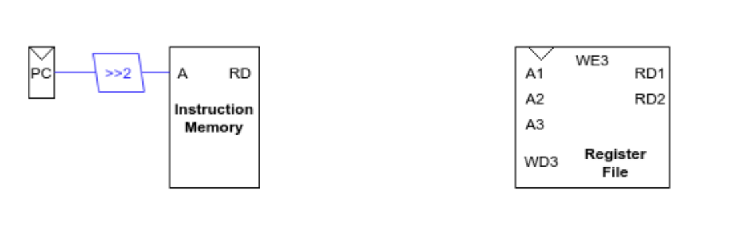

1. **Input rs1 and rs2 from instruction memory into A1 and A2 in register file respectively.**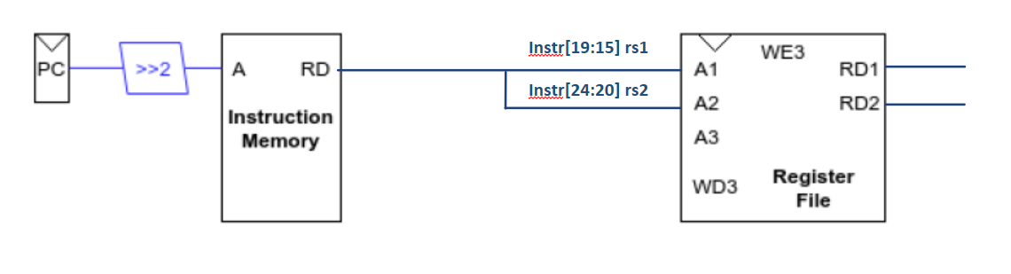
2. **Input srcA and srcB from RD1 and RD2 into ALU for computation.**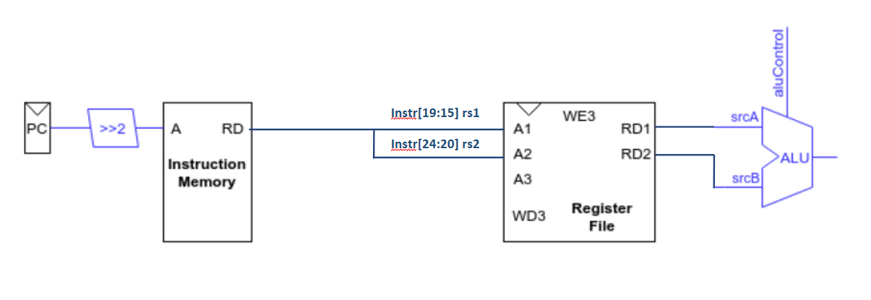
3. **Input rd from instruction memory to A3 in register file.**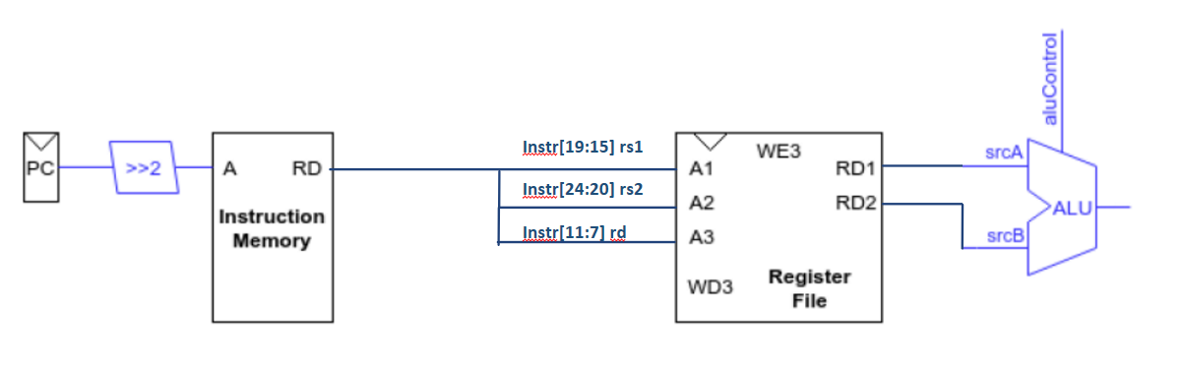
4. **Input the result of ALU into WD3 in register file and rewrite it.  
   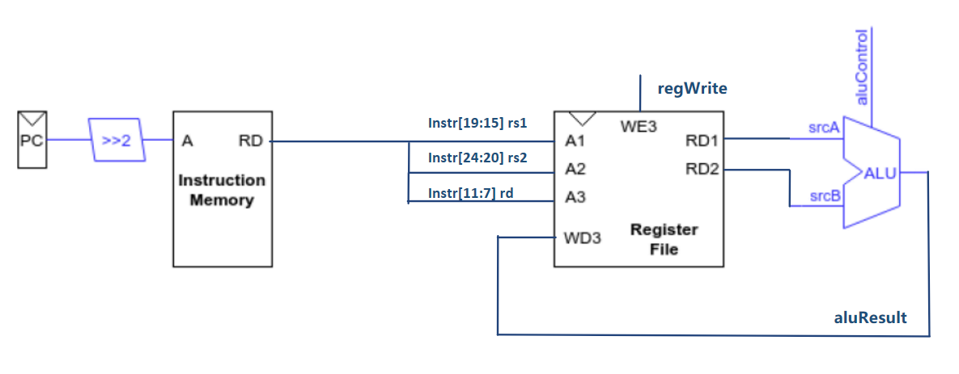**
5. **PC plus 4 and then go to the next instruction.  
   